***Web Systems & Technologies***

***ITL-226***

***Lab Journal 2***



**Student Name:** Kainat Zahra Alvi Sial

**Enrolment No:** 01-135231-040

**Class and Section:** BSIT-5B

**Department of Computer Science**

**BAHRIA UNIVERSITY, ISLAMABAD**

**Lab # 2: Introduction to HTML**

**Objectives:**

Learn about HTML basics.

**Tools Used:**

Visual Studio 2013.

**Submission Date: 15 FEB 2025**

**Evaluation: Signatures of Lab Engineer:**

**Task # 1:**

Create a Curriculum Vitae Profile of yourself with sections as objective, personal info, educational info, projects, certificates, experience & hobbies/skills. Headings of different sizes should be used.

Some text should be in italic and some in bold. Try to use all the HTML tags discussed in lab manual 02.

*DON’T use CSS. Use only HTML tags to create your CV.*

**Create a repository on GitHub with the name “Lab2”.**

**Download GitHub Desktop and commit your solution to the repository with appropriate messages.**

**Repository Link:**

https://github.com/kainatzahraalvisial/Lab2

**Procedure/Program:**

<!DOCTYPE html>

<html lang="en">

<head>

    <meta charset="UTF-8">

    <meta name="viewport" content="width=device-width">

    <title>Curriculum Vitae</title>

</head>

<body>

    <h1 style="text-align: left; padding: 10px;">---------------------------------------------------------------------------------------------------------------------------</h1>

    <h1 style="text-align: left; padding: 10px;"><u>

       <b> Kainat Zahra Alvi Sial</b></u>

    </h1>

    <h2> Personal Information: </h2>

    <ul>

        <li><b>Email:</b> zalvi@gmail.com</li>

        <li><b>Contact No :</b> +92342492394</li>

        <li><b>Address :</b> house no 23, abcd street, fgh city</li>

    </ul>

    <br/>

    <h2> Objective: </h2>

    <p>To secure a challenging position as a <i>Software Developer</i> where I can utilize my programming skills

        and contribute to the growth of the organization.

</p>

<br/>

<h2> Educational Information:</h2>

<table border="1" cellpadding="5" cellspacing="0">

    <tr>

        <th>Degree</th>

        <th>Institute</th>

        <th>Year</th>

        <th>Grade</th>

    </tr>

    <tr>

        <td>Bachelor of Science in Information Security</td>

        <td>Bahria University Islamabad</td>

        <td>2023 - Present</td>

        <td>3.5 CGPA</td>

    </tr>

    <tr>

        <td>Intermediate in Pre-Medical</td>

        <td>XYZ College</td>

        <td>2020 - 2023</td>

        <td>90%</td>

    </tr>

    <tr>

        <td>Matriculation in Science</td>

        <td>ABC School</td>

        <td>2018 - 2020</td>

        <td>92%</td>

    </tr>

</table>

<br/>

<h2> Projects:</h2>

<ol>

    <li>

        <b>Stealthy Striker</b> - A 2D action game.

        <ul>

            <li>Technologies used:  OOP, C++, SFML</li>

            <li>Role:  Full-Stack developer</li>

        </ul>

    </li>

    <li>

        <b>BST-Visualizer</b> - An engaging and educational tool for understanding Binary Search Trees through interactive visualization.

        <ul>

            <li>Technologies used:  DSA, C++, SFML</li>

            <li>Role:  Full-Stack developer</li>

        </ul>

    </li>

</ol>

<br/>

<h2>Certifications</h2>

    <ul>

        <li>Certified Web Developer - 2023</li>

        <li>JavaScript Essentials - 2022</li>

        <li>Python Programming - 2021</li>

    </ul>

    <br/>

    <h2>Experience</h2>

    <h3>Intern - ABC Software House</h3>

    <p>

        Worked as a <i>Front-End Developer</i> and contributed to the design and development of responsive websites.

    </p>

    <ul>

        <li>Designed UI components for various client projects.</li>

        <li>Collaborated with the back-end team to integrate APIs.</li>

    </ul>

    <br/>

    <h2>Skills</h2>

    <ul>

        <li>Programming Languages: <b>HTML</b>, <b>CSS</b>, <b>C++</b></li>

        <li>Data structures and algorithms</li>

        <li>Database design and development</li>

        <li>Mobile application development</li>

        <li>Problem-Solving & Analytical Thinking</li>

    </ul>

    <br/>

    <h2>Hobbies</h2>

    <ul>

        <li>User Interface designing</li>

        <li>Reading Tech related blogs</li>

    </ul>

    <br/>

    <p style="text-align: center;">&copy; 2025 Kainat Zahra Alvi Sial | All Rights Reserved</p>

</body>

</html>

**Result/Output:**

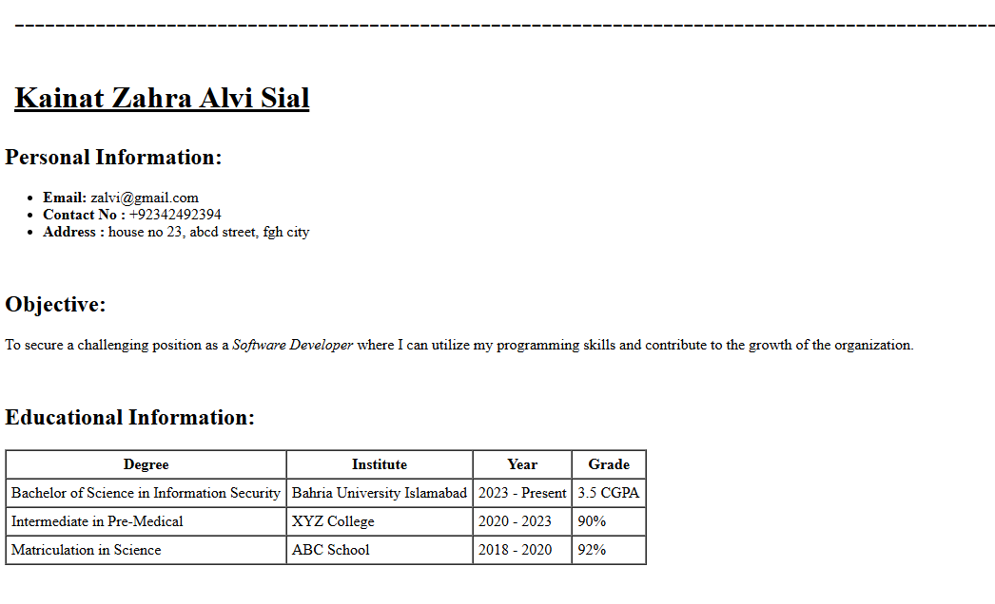

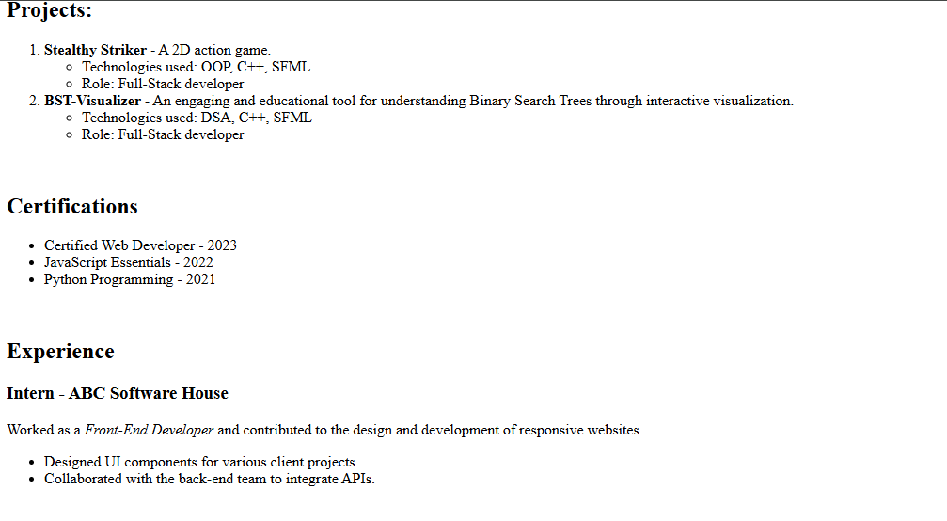

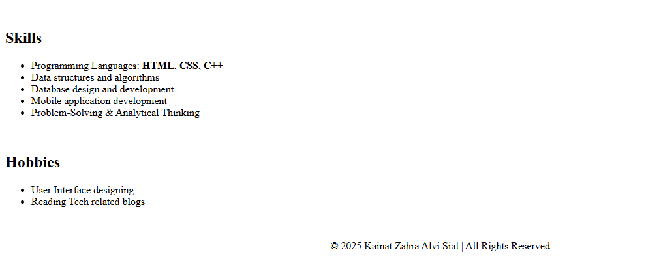

**Analysis/Conclusion:**

In this lab exercise, I created a CV using only HTML tags without any CSS, which helped me understand how to structure content using headings, paragraphs, lists, and tables. This approach highlighted the importance of semantic HTML for organized and readable documents, even without advanced styling.